M Akhtar – 242756
BSCS-5C-Fall-2026
Full Stack development Lab
Lab 6

Task -01 output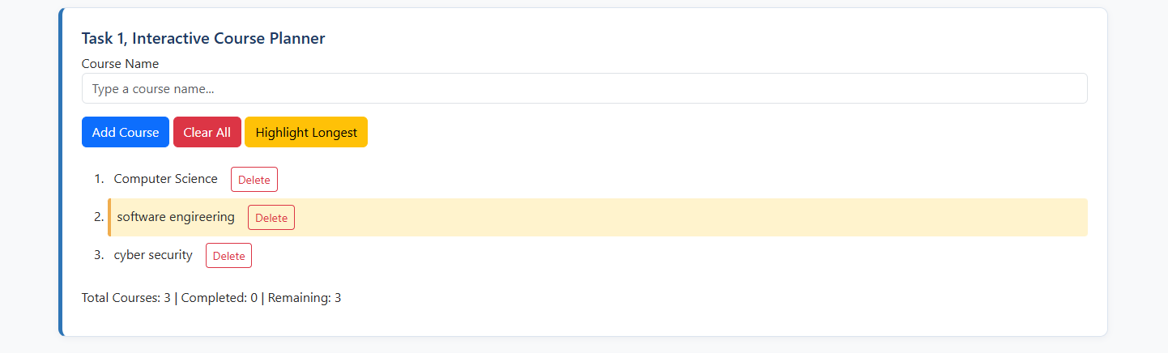

Task - 02 Output
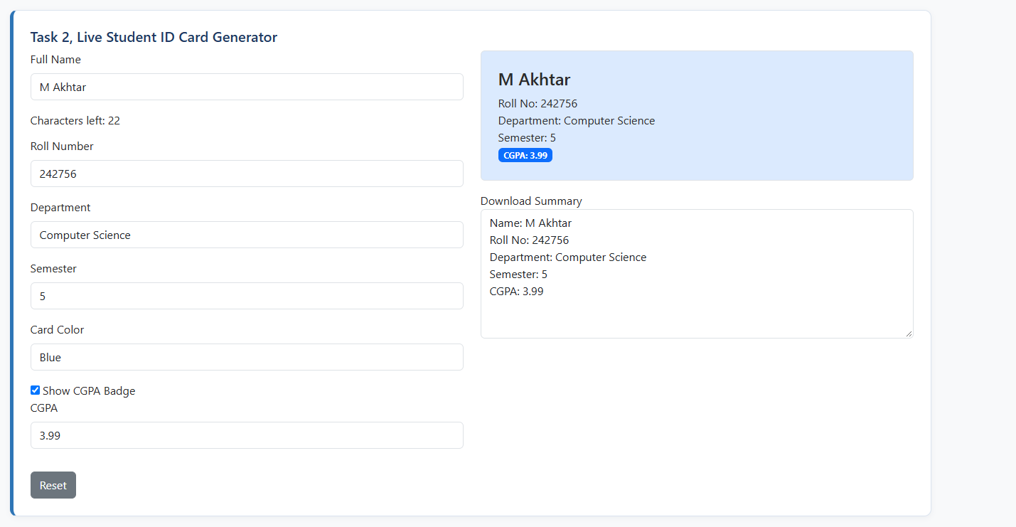

Task - 03 OUTPUT
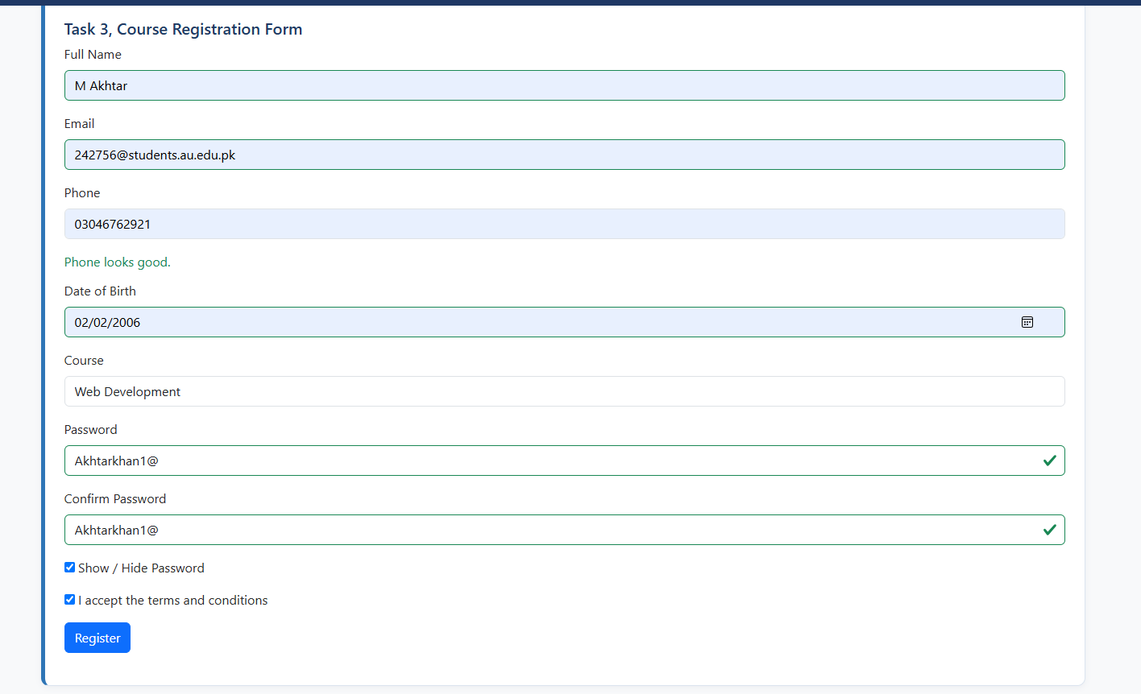
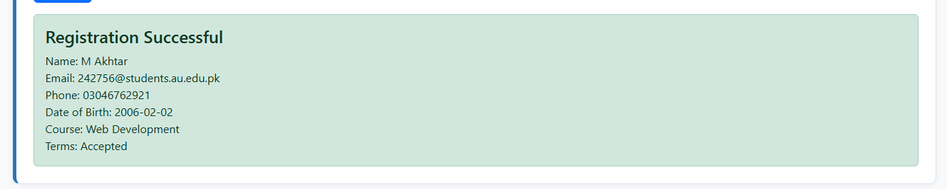

Task – 04 Output


